# What the Heck are we Doing?

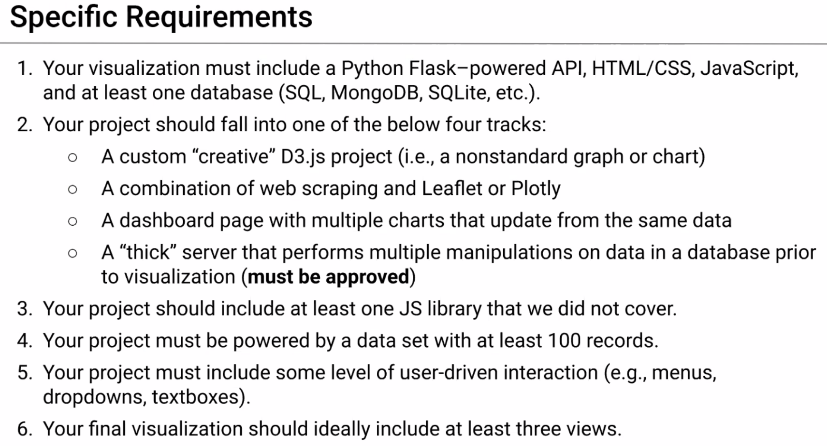

# Why are we using Flask?

Earlier in class we learned how to use flask to connect to a database and display information as a JSON. As we have been learning javascript we have been learning to do different things with JSON data. So the first step of our project will be to throw our data in a database and then create a flask script to perform some queries to give us the data in a JSON format.

* Flask read info in json format

# How can we structure the work?

* Create code for flask app which will pull all the data from the database
  + Team members can reference it when doing their part
* Perform a query for us to create a scatter graph
* The front end developer can plug and play with @app.route("/api…)

1. Create specific div tags for people’s scripts to add data to the page

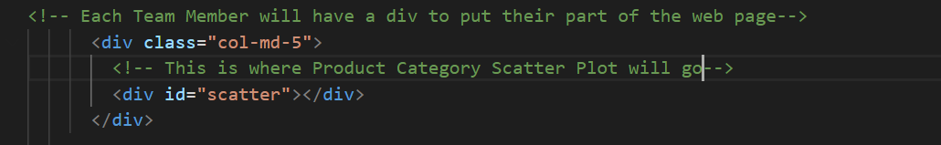

In the example above is a div named scatter this is what the javascript will reference when creating the graph for the page.

Thought:

* The person making the web page can assign each team member a div for doing their part.
* On the bottom of the web page in the scripts section they will just need to add everyone’s script file.

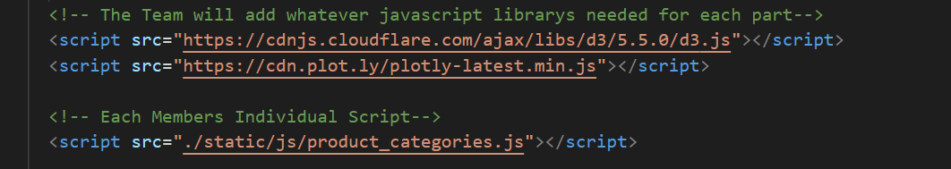

In the example above the product_categories.js file will be the script file which will create our scatter graph.

# Setting Up Flask

Refresher:

10-Advanced-Data-Storage-and-Retrieval.

In this folder is a python script that is named app.py

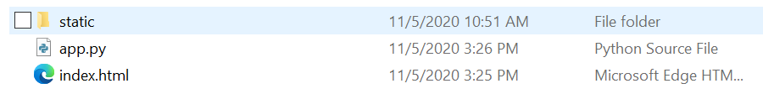

* Open it in VS Code
  + Use the jupyter notebook for querying our data and creating our database.

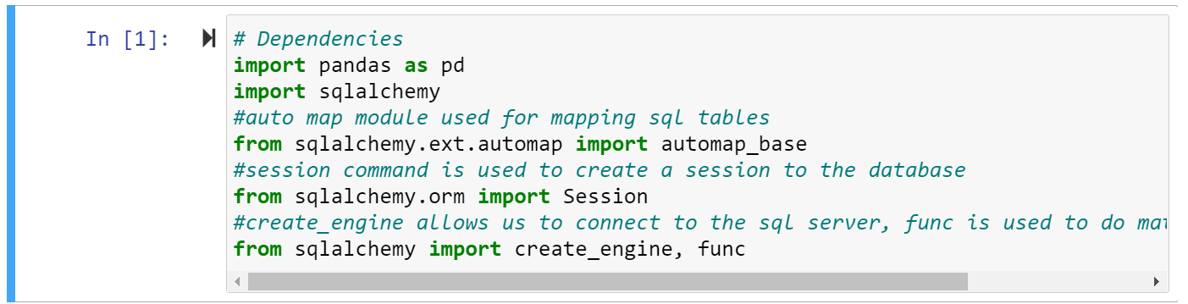

* Look at the first lines of the flask app

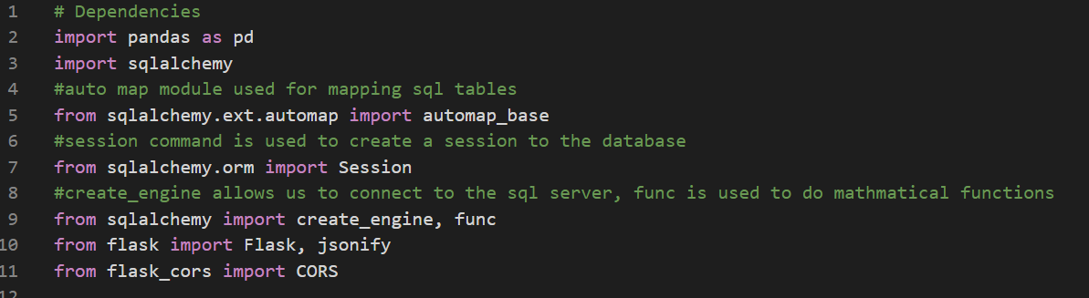

* You can see the code is the same except the last two lines which are just special modules to get flask to work.

The next part of our script is just adding the code for connecting to our database.

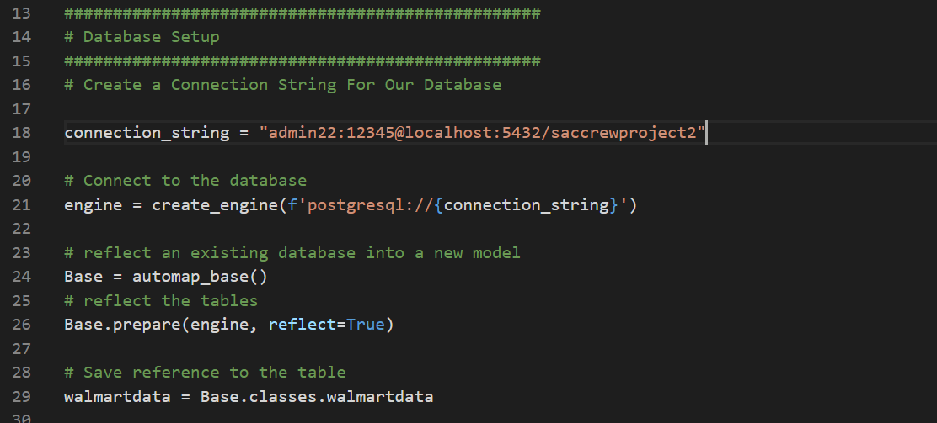

* The last part of the flask script just runs the sql queries.
  + which just pulls all the data from the database
  + The last query just counts how many products in our database we have for each category.

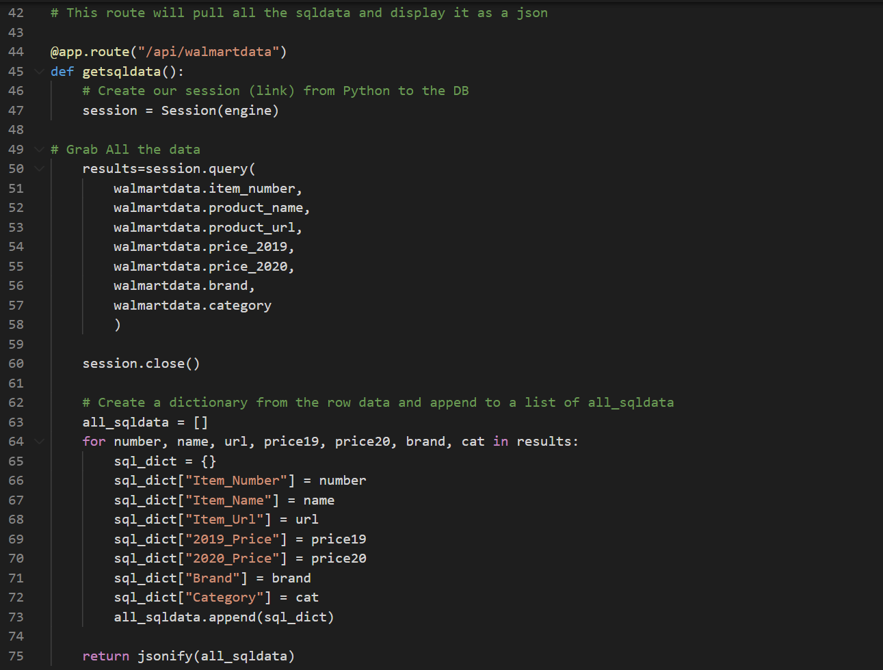

The last query just counts how many products in our database we have for each category.

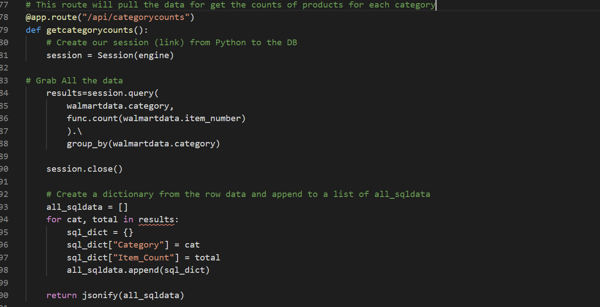

Thought:

If this app.py file is used as a template any new query will follow this format and add the code above line 104.

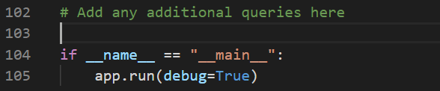

# **Do I need remove from flask_cors import CORS?**

If so:

* Add module (reference mission to mars)
* from flask import Flask, render_template, redirect
  + Replace line 11
  + Copy from app.py file from mission to mars line 12-20
  + Insert line 41
    - Delete anything mongo
    - Clean up return render_template("index.html")
  + 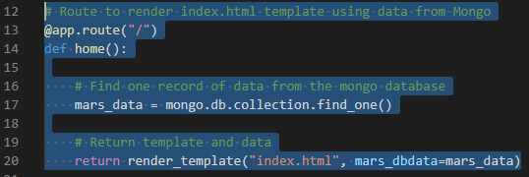
  + Remove line 36 in my original flask
* Folder structure
  + If this change is made I need to:
    - Create temples folder> index.html
    - Move static folder >templates

# Running The Flask Script

In VS Code just hit the run button on the top right

If everything is working you will see this in the console

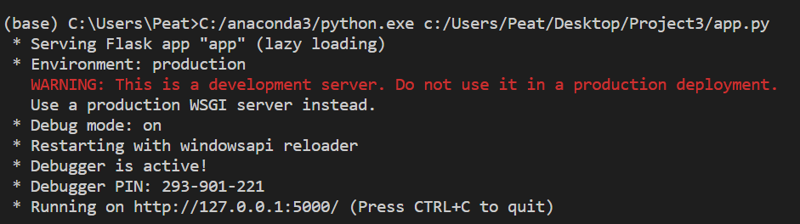

Now to test the script we just need to go to two websites.

Each query we put in our flask script starts with a line that looks like this



So in a web browser navigate to this site

<http://127.0.0.1:5000/api/walmartdata>

If everything is working you should see a huge JSON which represents all our data in our database.

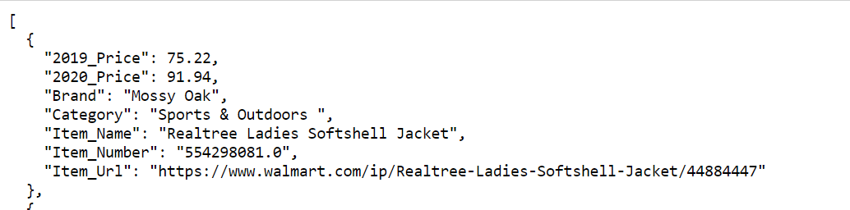

Now lets check out the data we are going to use for creating our chart

Navigate to this site

<http://127.0.0.1:5000/api/categorycounts>

If everything is working correctly you will see this

